**Participant Initiated Non-RID Activities** 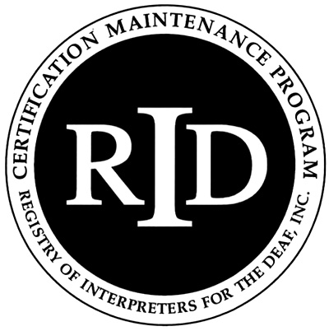



**(PINRA)**

This form will be used if a CMP Participant plans to attend another organization’s workshop, conference, formal in-service training or activity. The RID Approved Sponsor will determine if the activity is appropriate for CEUs.

**Before the start of the activity/conference, this section should be filled out**

**and signed by both the participant and RID Approved Sponsor:**

Participant Name: _____________________________________ RID Member #: _______________

Participant Address ___________________________________________________________________

Email:____________________________­­__________ Phone # ________________________________

Activity/Conference Name: ____________________________________________________________

Activity/Conference Theme or Focus (attach brochure/flyer) __________________________________

Date and Times of activities you will attend: _______________________________________________

Total number of CEUs to be awarded: _______ Circle content area: Professional Studies General Studies

I certify that this activity/conference represents a valid and verifiable Continuing Education Experience

that exceeds routine employment responsibilities.

Participant Signature: ____________________________________ Date: ___________________

=========================================================================== Name and Code of RID Approved Sponsor ______________________________________________

I certify that I received this activity plan prior to the start of the activity/conference and I agree to sponsor this Continuing Education Experience. I will verify successful completion prior to awarding CEUs.

RID Sponsor Administrator Name:___________________________Signature:___________________________

RID Sponsor Code: ___________________________Date:_______________________________

**This section should be filled out and signed upon *completion* of the activity/conference:**

Activity Code Number __ __ __ __. __ __ __ __ . __ CEUs Awarded: _______

I have verified that the participant attended this activity/conference and that the activities listed are appropriate educational experiences which should be awarded the number of CEUs denoted above.

RID Approved Sponsor Signature Administrator: ______________________________________ Date:__________

**The Participant must send documentation of attendance to the Sponsor upon completion of the activity. The Sponsor must file this form with RID online at** [**www.rid.org**](http://www.rid.org) **within 45 days of the completion of the activity/conference.**

**Updated March 2008**